Draw the Path: Portfolio Sitemap + Toolkit
Muhammad Hamza Nawaz — General AI Fluency track, FlyRank Internship

1. Sitemap Sketch
One person, one path: Home/Hero states the claim, Work proves it with case studies, About builds trust, Contact drives the one action — getting a hiring manager or client to email me.
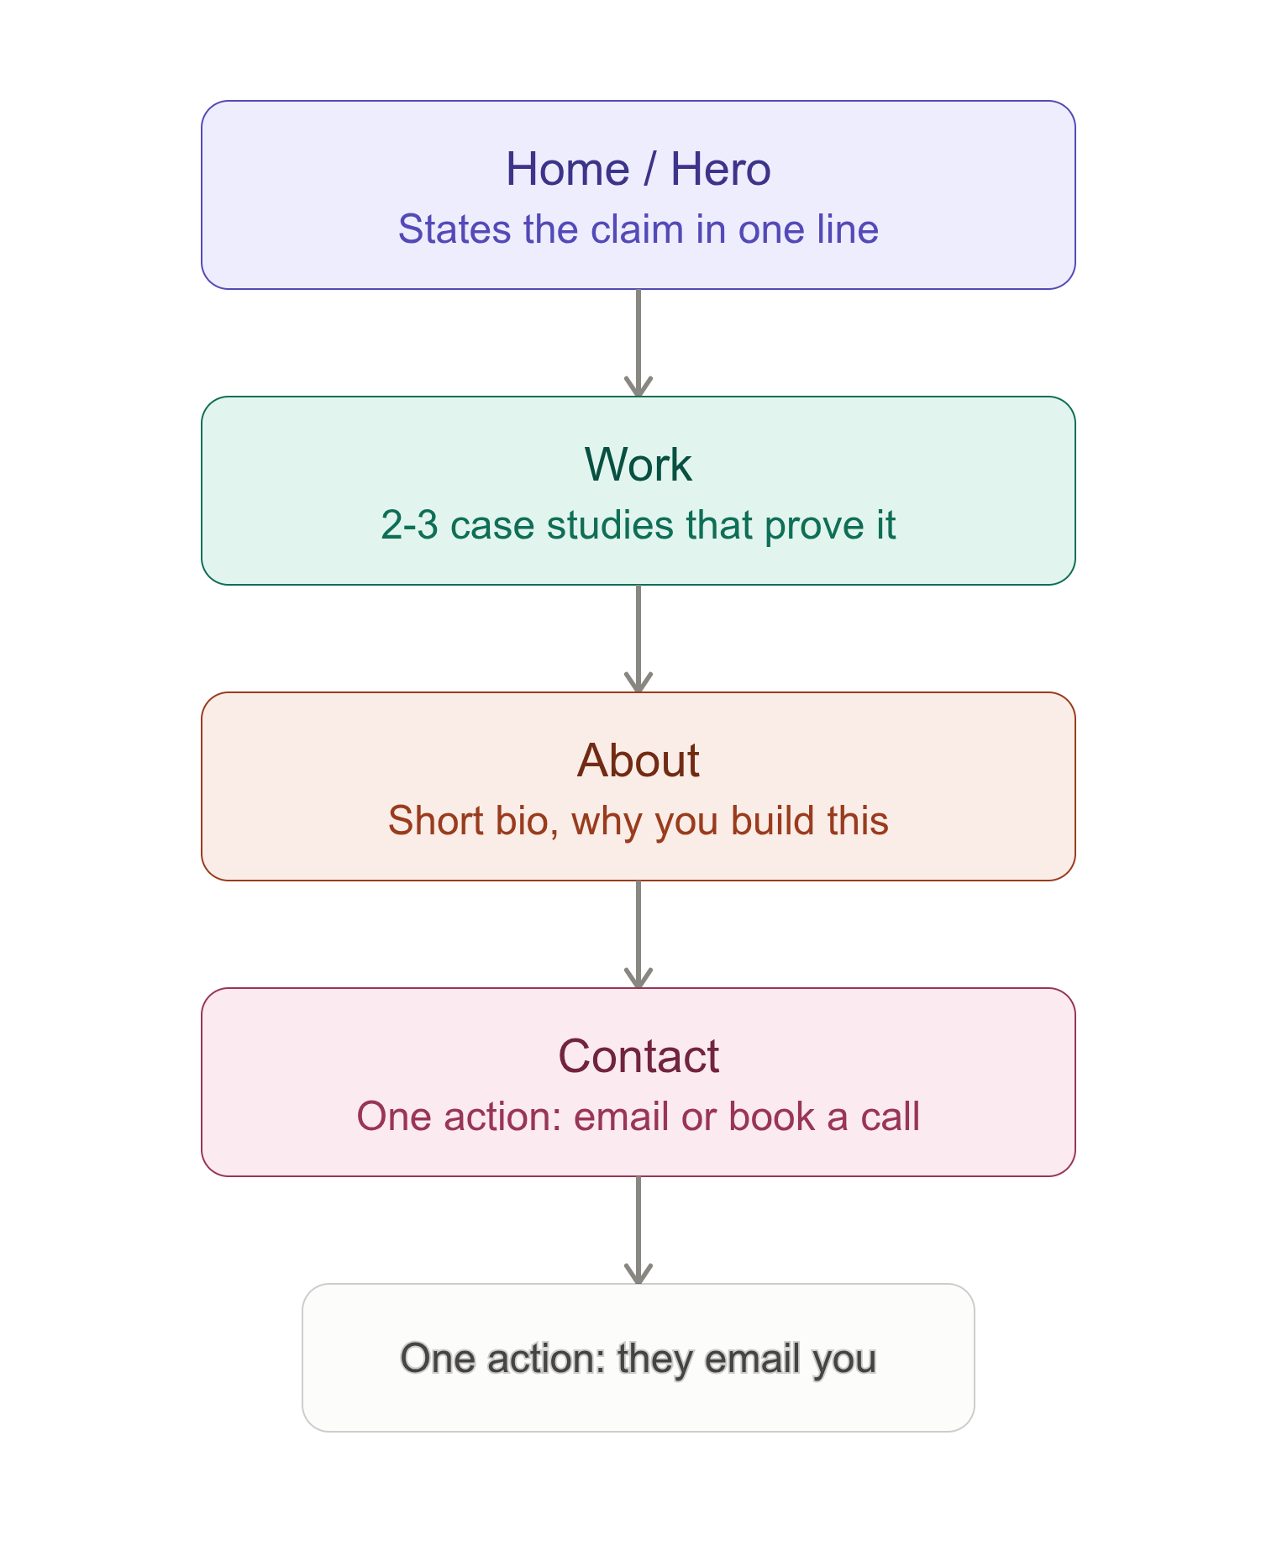

2. Toolkit
Accounts set up: Claude, ChatGPT, Gemini, Perplexity.

3. Claude Project — Configured
Created a Project ("Portfolio Build") with my proof statement pasted into custom instructions, plus a request for Claude to act as a tutor for this 8-week build — asking questions and checking my reasoning rather than just handing me finished answers.
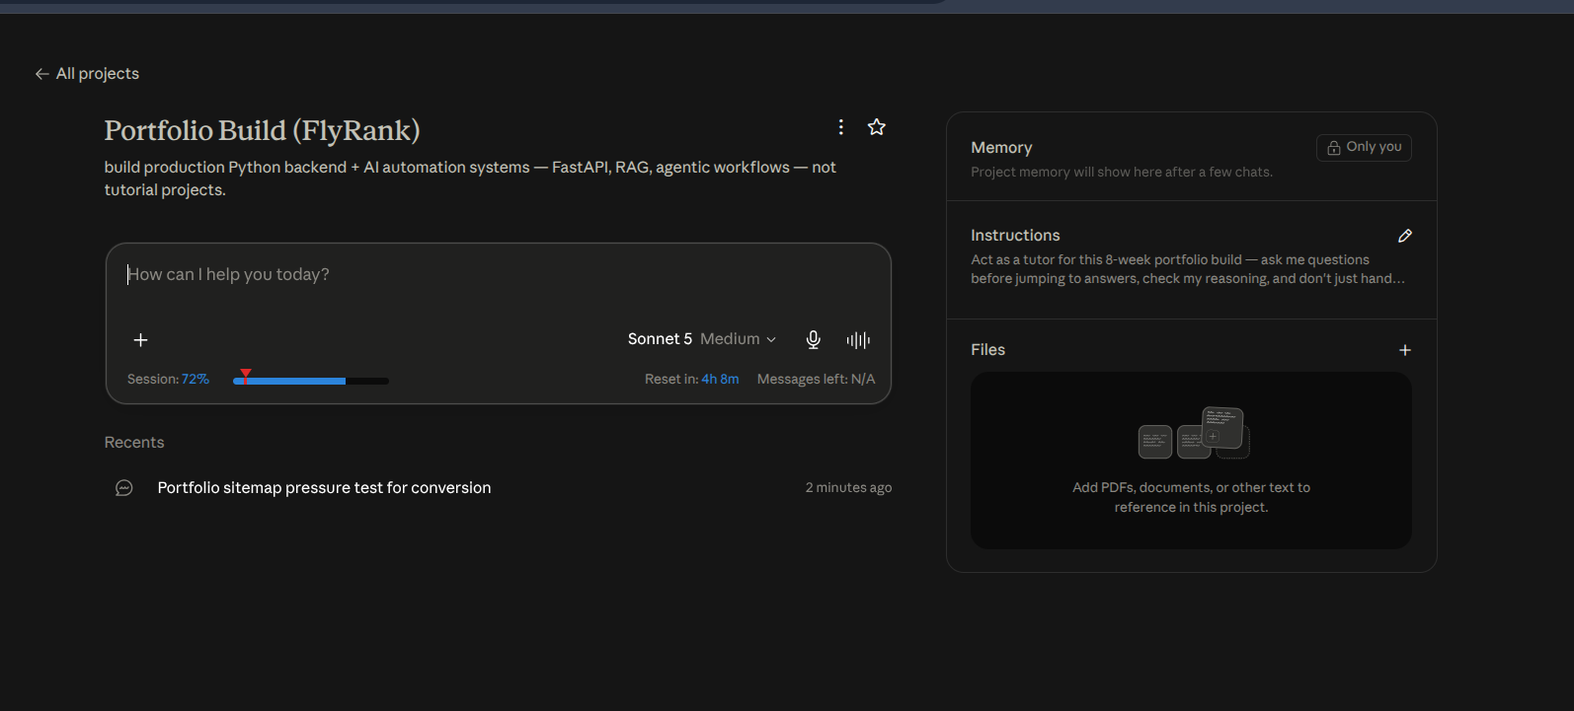

4. Pressure-Test Prompt + Output
Prompt: "Here's my portfolio sitemap: Home/Hero (states my claim), Work (case studies: HireFlow, NeoRetail, DentAI), About (short bio), Contact (one action: they email me). My one target action is getting a hiring manager or client to email me. Pressure-test this against my claim and my one action — does every page earn its place? What would you cut, add, or reorder?"
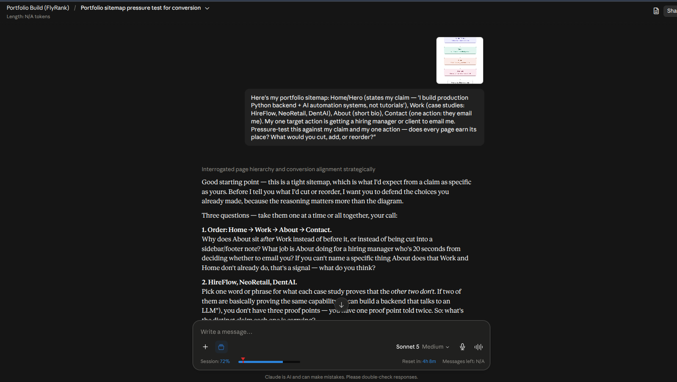

What I'd change
The pressure-test surfaced a real gap: my sitemap read as a linear chain (Home → Work → About → Contact), but that's not how people actually land on a portfolio — someone could land directly on one case study and be ready to email me immediately. I'm going to add a persistent, low-key contact link (nav bar + end of every case study) instead of making Contact only reachable at the end of the chain, without turning it into a page-by-page CTA that nags the visitor.

